- FooEngine.h (тестовый двигатель)

#pragma once

#include "AEngine.h"

#include <iostream>

#include <thread>

#include <chrono>

class FooEngine : public AEngine {

private:

std::string lastCommand;

int lastCommandTime;

bool engineOn;

public:

FooEngine() : lastCommand("none"), lastCommandTime(0), engineOn(false) {}

void turnOn() {

engineOn = true;

std::cout << "[FooEngine] ДВИГАТЕЛЬ ВКЛЮЧЕН" << std::endl;

}

void turnOff() {

engineOn = false;

std::cout << "[FooEngine] ДВИГАТЕЛЬ ВЫКЛЮЧЕН" << std::endl;

}

bool isEngineOn() const {

return engineOn;

}

void forward(int time_ms) override {

if (!engineOn) {

std::cout << "[FooEngine] ОШИБКА: двигатель выключен!" << std::endl;

return;

}

std::cout << "[FooEngine] ВПЕРЕД " << time_ms << " мс" << std::endl;

std::this_thread::sleep_for(std::chrono::milliseconds(time_ms));

lastCommand = "forward";

lastCommandTime = time_ms;

}

void backward(int time_ms) override {

if (!engineOn) {

std::cout << "[FooEngine] ОШИБКА: двигатель выключен!" << std::endl;

return;

}

std::cout << "[FooEngine] НАЗАД " << time_ms << " мс" << std::endl;

std::this_thread::sleep_for(std::chrono::milliseconds(time_ms));

lastCommand = "backward";

lastCommandTime = time_ms;

}

void left(int time_ms) override {

if (!engineOn) {

std::cout << "[FooEngine] ОШИБКА: двигатель выключен!" << std::endl;

return;

}

std::cout << "[FooEngine] ВЛЕВО " << time_ms << " мс" << std::endl;

std::this_thread::sleep_for(std::chrono::milliseconds(time_ms));

lastCommand = "left";

lastCommandTime = time_ms;

}

void right(int time_ms) override {

if (!engineOn) {

std::cout << "[FooEngine] ОШИБКА: двигатель выключен!" << std::endl;

return;

}

std::cout << "[FooEngine] ВПРАВО " << time_ms << " мс" << std::endl;

std::this_thread::sleep_for(std::chrono::milliseconds(time_ms));

lastCommand = "right";

lastCommandTime = time_ms;

}

void stop() override {

if (!engineOn) {

std::cout << "[FooEngine] ОШИБКА: двигатель выключен!" << std::endl;

return;

}

std::cout << "[FooEngine] СТОП" << std::endl;

lastCommand = "stop";

lastCommandTime = 0;

}

void printStatus() {

std::cout << "[FooEngine] Статус: двигатель " << (engineOn ? "ВКЛЮЧЕН" : "ВЫКЛЮЧЕН");

std::cout << ", последняя команда = " << lastCommand;

if (lastCommandTime > 0) {

std::cout << " (" << lastCommandTime << " мс)";

}

std::cout << std::endl;

}

};2. FooCmdReceiver.h (тестовый приемник команд)
cpp
#pragma once
#include "ACmdReceiver.h"
#include <iostream>
#include <string>

class FooCmdReceiver : public ACmdReceiver {
private:
bool interactiveMode;

public:
FooCmdReceiver() : interactiveMode(false) {}

void startInteractiveMode() {
interactiveMode = true;
std::cout << "Интерактивный режим включен. Введите команду (help для справки)" << std::endl;
}

std::string receive() override {
if (interactiveMode) {
std::string cmd;
std::cout << "> ";
std::getline(std::cin, cmd);
return cmd;
}
return "";
}
};

3. AEngine.h (абстрактный класс двигателя)

cpp
#pragma once

class AEngine {
public:
virtual void forward(int time_ms) = 0;
virtual void backward(int time_ms) = 0;
virtual void left(int time_ms) = 0;
virtual void right(int time_ms) = 0;
virtual void stop() = 0;
virtual ~AEngine() {}
};

4. ACmdReceiver.h (абстрактный класс приёмника команд)

#pragma once
#include <string>
class ACmdReceiver {
public:
virtual std::string receive() = 0;
virtual ~ACmdReceiver() {}
};
5. Main
#include <iostream>
#include <sstream>
#include <windows.h>
#include "FooEngine.h"
#include "FooCmdReceiver.h"

int main() {

SetConsoleOutputCP(CP_UTF8);
SetConsoleCP(CP_UTF8);

FooEngine engine;
FooCmdReceiver receiver;

receiver.startInteractiveMode();
engine.turnOn();

std::cout << "Доступные команды: forward <ms>, left <ms>, right <ms>, stop, exit\n";

while (true) {
std::string input = receiver.receive();

if (input.empty()) {
continue;
}

std::istringstream iss(input);
std::string command;
int time_ms = 0;

iss >> command;

if (command == "forward") {
iss >> time_ms;
engine.forward(time_ms);
} else if (command == "left") {
iss >> time_ms;
engine.left(time_ms);
} else if (command == "right") {
iss >> time_ms;
engine.right(time_ms);
} else if (command == "stop") {
engine.stop();
} else if (command == "exit") {
engine.turnOff();
std::cout << "Выход из программы\n";
break;
} else {
std::cout << "Неизвестная команда\n";
}
}

return 0;
}
6. Диаграмма классов
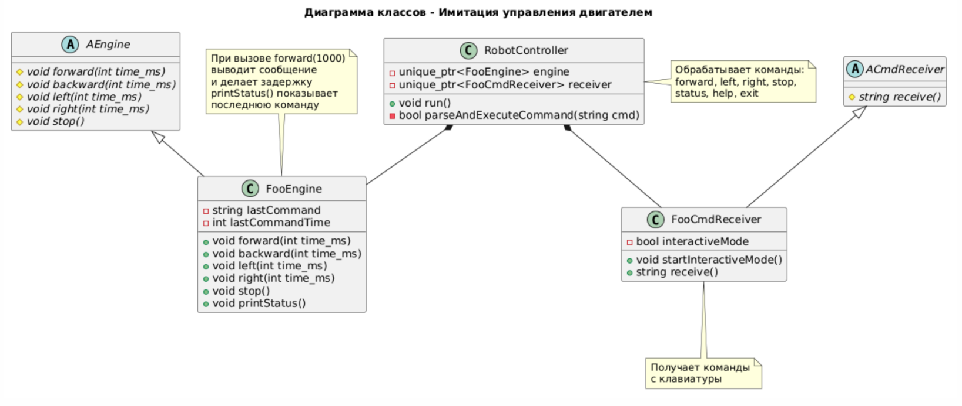

@startuml
title Диаграмма классов - Имитация управления двигателем

abstract class AEngine {
#{abstract} void forward(int time_ms)
#{abstract} void backward(int time_ms)
#{abstract} void left(int time_ms)
#{abstract} void right(int time_ms)
#{abstract} void stop()
}

abstract class ACmdReceiver {
#{abstract} string receive()
}

class FooEngine {
-string lastCommand
-int lastCommandTime
+void forward(int time_ms)
+void backward(int time_ms)
+void left(int time_ms)
+void right(int time_ms)
+void stop()
+void printStatus()
}

class FooCmdReceiver {
-bool interactiveMode
+void startInteractiveMode()
+string receive()
}

class RobotController {
-unique_ptr<FooEngine> engine
-unique_ptr<FooCmdReceiver> receiver
+void run()
-bool parseAndExecuteCommand(string cmd)
}

AEngine <|-- FooEngine
ACmdReceiver <|-- FooCmdReceiver
RobotController *-- FooEngine
RobotController *-- FooCmdReceiver

note top of FooEngine : При вызове forward(1000)\nвыводит сообщение\nи делает задержку\nprintStatus() показывает\nпоследнюю команду

note bottom of FooCmdReceiver : Получает команды\nс клавиатуры

note right of RobotController : Обрабатывает команды:\nforward, left, right, stop,\nstatus, help, exit
@enduml

